Quantum Europe: a New Era of Technology

# Introduction

Dear Guest,

It is our great pleasure to welcome you to the Quantum Europe 2016 Conference in Amsterdam. It promises to be an exciting and strategic meeting in the context of the Quantum Manifesto and the recent announcement of the Flagship Initiative. Together with a broad team, we have tried to set-up a program that is both interesting and innovative in its setup. We have invited highly respected speakers from science, industry and policy communities around the world to allow for valuable dialogues within the triple-helix. This dialogue is vital for the strategy needed for Europe to stay at the forefront of the second quantum revolution. We also organized an exhibition to demonstrate state-of -the-art applications and mind boggling effects of quantum technologies.

Thank you for attending our conference and bringing in your expertise; we hope you will enjoy the program!

On behalf of the hosts, program committee and organizers,

Freeke Heijman, EU Presidency  
Thierry van der Pyl, European Commission  
Leo Kouwenhoven, QuTech  
Tommaso Calarco, IQST Ulm

# Programme

Content goes here

# Bios of plenary speakers

**Hosts**

## Henk Kamp, Minister of Economic Affairs of the Netherlands

Henk Kamp has been Minister of Economic Affairs of the Netherlands since 2012. His portfolio includes industry, innovation, energy policy, mining, trade and tourism. Promoting sustainable and strong economic growth is a priority for Mr Kamp, who during his long political career has also served as Minister of Housing, Spatial Planning and the Environment, Minister of Defence and Minister of Social Affairs and Employment. In the context of the Dutch Presidency of the Council of the European Union, the minister is striving to consolidate the EU’s leading position in the development of quantum technologies. The ‘Quantum Manifesto’, drawn up under the Dutch Presidency, offers guidance in this regard.

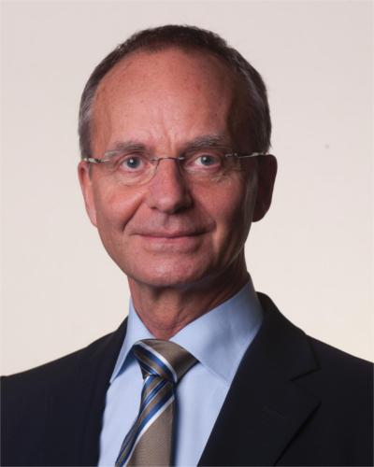

## Gü​​​​nther Oettinger, EU Commissioner for Digital Economy and Society

Oettinger has had a longstanding political career and several high profile roles, most notably the European Commissioner for Energy from 2010 to 2014, and is currently the Commissioner for Digital Economy an Society. He has a background in Law and acted as a lawyer and CEO of an audit and tax consultancy. He is responsible for the ongoing reform of the EU’s telecom rules, supporting the deployment of high-quality, digital infrastructure and the development of measures to ensure online communications are more secure.

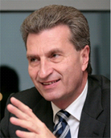

## Leo Kouwenhoven, Scientific Director of QuTech, Delft

Kouwenhoven is the founding director of Qutech, the Advanced Research Center on Quantum Technologies. He is also a Professor at the Delft University of Technology in the field of quantum nanoscience, where he received his Ph.D. cum laude. He specialises in the electronic properties of nanostructures. He has received a large number of awards for his contribution to both reaching and his field, and is a recipient of the Spinoza Prize, which is the highest scientific award in the Netherlands.

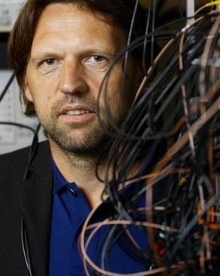

**Plenary speakers**

## Alain Aspect, Augustin Fresnel Professor at the Institut d’Optique Graduate School Paris

He was awarded the Niels Bohr Medal in 2013 for his work on Bell’s inequalities tests. These tests made a large contribution to the discussions between Albert Einstein and Niels Bohr, and demonstrated quantum entanglement, a phenomenon which is at the heart of quantum information research today. This research was undertaken in the Laboratoire Charles Fabry (Institut d’Optique Graduate School/CNRS) and the results were examined in his doctoral thesis, published in 1983. His more current research focuses on quantum simulators, quantum atomic optics and atomic lasers.

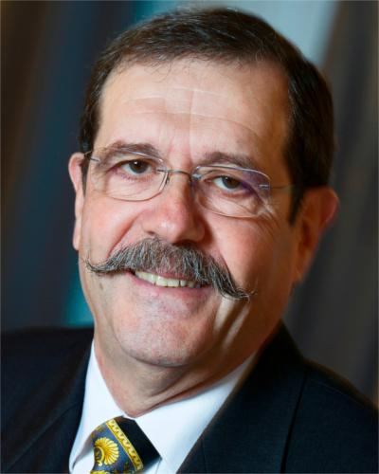

## Jo De Boeck, Senior Vice President and Chief Technology Officer at IMEC

Jo De Boeck received his engineering degree in 1986 and his PhD degree in 1991 from the University of Leuven. Since 1991 he is a staff member of imec (Leuven). He has been a NATO Science Fellow at Bellcore (USA, 1991-92). In 2003 he became Associate Vice President at IMEC for the Microsystems division and in 2005 started Holst Centre (Eindhoven) and became CEO of IMEC-Netherlands. From 2009 to 2011 he headed imec’s unit Smart Systems and Energy Technology as Senior Vice President in the imec group. In 2011 he was appointed CTO of imec corporate. He is part-time professor at the KU Leuven and visiting professor at the TU Delft.

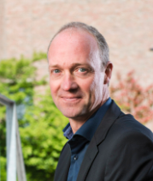

## Michael Bolle, President of Corporate Research and Development, Robert Bosch GmbH

Bolle received his engineering doctorate degree in electrical engineering summa cum laude, and now serves as president of Corporate Research and Development at Bosch, a world-class electronics and engineering company with a broad spectrum of ongoing research and development. Bolle leads research in various fields including information technology and quantum transportation and storage.

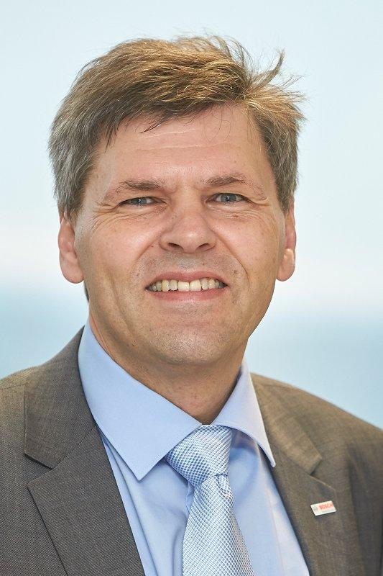

## Tommaso Calarco, Professor and Director of the Center for Integrated Quantum Science and Technology, University of Ulm

He is a professor in quantum information processing, director of the Institute of Comlpex Quantum Systems at the University of Ulm since 2011, and of the Center for Integrated Quantum Science and Technology since 2014. He is also currently Chairman of the Strategic Advisory Board of the EC-FET Coordination Action “Quantum Technologies in Europe”. His research focusses on quantum optimal control and complex quantum systems, with applications in quantum technologies from quantum sensing to quantum communication and quantum simulation.

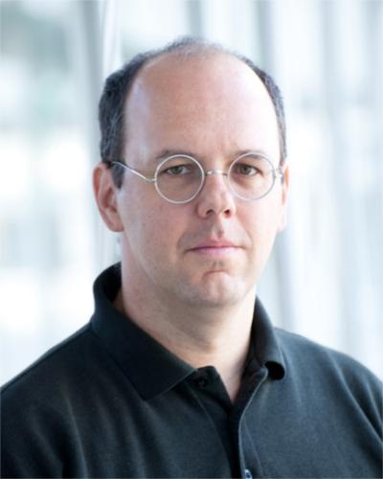

## Serge Haroche, Professor at the Collège de France

Was awarded the 2012 Nobel Prize for Physics jointly with David Wineland for “ground-breaking experimental methods that enable measuring and manipulation of individual quantum systems.” His main field of research is in quantum optics and quantum information science, he is principally known for proving quantum decoherence by experimental observation and has made important contributions to Cavity Quantum Electrodynamics. His recent research has been on the development of super-high finesse cavities capable of holding photons for over a tenth of a second.

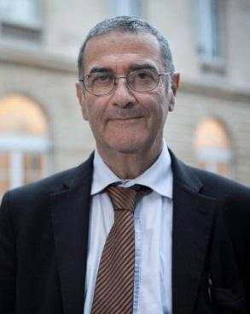

## Gail Kent, Acting Deputy Director General at DG CONNECT, European Commission

Since January 2016, Gail Kent is the acting DDG for the Research Directorates in DG Connect and has been Director of Resources in DG CONNECT since January 2014.

An economist from UCL, and a Cranfield MBA, her career has been a mix of private sector management in the retail sector followed by 20 years in the European Commission in mainly financial and human resource management roles across several DGs. She has also 2 years of high level experience of policy advice at the heart of the college of Commissioners. She thus has an in-depth knowledge of Commission policies and procedures as well as experience of a political role.

Working in the DG at the heart of Digital policy and related ICT research funding, Gail is committed to 'walking the talk' in the area of public sector modernisation and creativity, and ensuring research funding reflects and links into digital policy priorities.

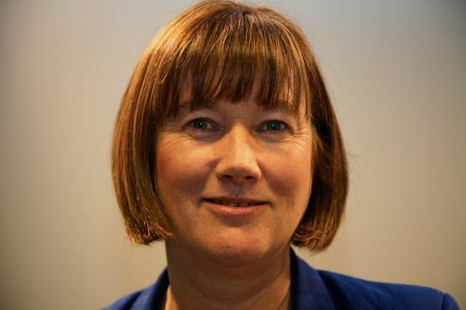

## Sir Peter Knight, Professor at the Imperial College London

Knight holds the position of Senior Research Investigator in the Physics Department at Imperial College and Senior Fellow in Residence at the Kavli Royal Society International Center at Chicheley Hall, and has contributed greatly to the field of quantum optics. He was knighted in 2005 for his work in optical physics. His research is primarily focused on theoretical quantum optics, strong field physics and quantum information science. He is member of the UK quantum technologies strategic advisory board.

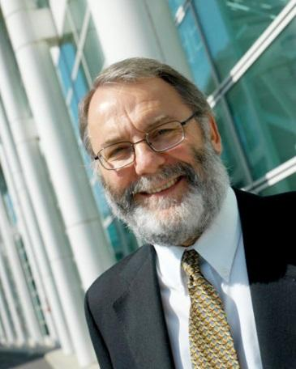

## Paul de Krom, CEO of the Netherlands Organisation for Applied Scientific Research (TNO)

De Krom holds per March 2015 the position of CEO of TNO, the Netherlands Organisation for Applied Scientific Research. His experience ranges from various managerial and board positions to Secretary of State for Social Affairs and Employment of the Netherlands from 2010 to 2012. TNO and the Delft University of Technology joined forces in 2014 to found QuTech, the Advanced Research Center on Quantum Technologies. QuTech aims to develop technology for quantum computers and quantum internet.

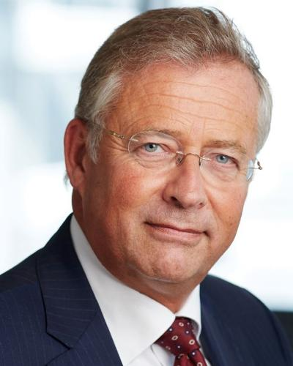

## Mike Lazaridis, Co-Founder and Managing Partner at Quantum Valley Investments

Mike Lazaridis, is Managing Partner and Co-Founder of Quantum Valley Investments (QVI) in Waterloo, Ontario. QVI provides financial and intellectual capital to help transform quantum breakthroughs into commercially viable products and technologies. It is Mike’s latest venture in more than a 15 years of work aimed at creating a “Quantum Valley” in Canada by bringing the world’s best minds in physics, engineering, mathematics, computer and materials sciences together to collaborate on cutting-edge quantum research.

In 1984, Mike co-founded Research In Motion (now BlackBerry) where he invented the BlackBerry device, created the smartphone industry, and built Canada’s largest global tech business. He is recognised for his exceptional vision and innovation in the field of wireless communication.

Mike is the Founder and Board Chair of both the Perimeter Institute for Theoretical Physics and the Institute for Quantum Computing at the University of Waterloo. Both of which are transforming physics research and education in Canada and beyond.

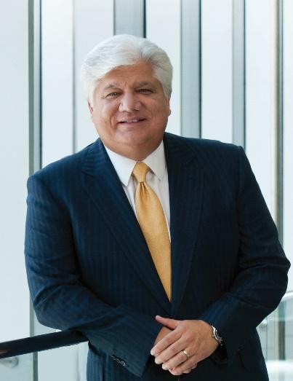

## Bertholt Leeftink, Director-General Enterprise and Innovation at the Dutch Ministry of Economic Affairs

Received his Ph.D. in macroeconomics at the University of Amsterdam, and now oversees the facilitation of entrepreneurship and innovation through the Dutch Ministry of Economic Affairs. The Ministry aims at stimulating Dutch knowledge-driven industries to help solve global challenges by innovative solutions. As such, innovative fields such as quantum computation are receiving generous support.

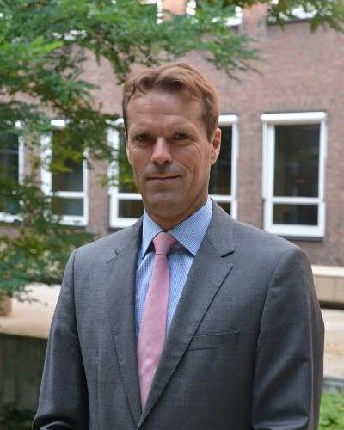

## Charles Marcus, Villum Kann Rasmussen Professor at the University of Copenhagen

Marcus was awarded the prize for Research Excellence in Nanotechnology in 2014 for his outstanding research. Marcus received his Ph.D. from Harvard University and was Scientific Director of the Harvard Center for Nanoscale Systems from 2004 to 2009. He currently holds the position of director of the Center for Quantum Devices at the Niels Bohr Institute at the University of Copenhagen. His research focusses on quantum coherence in electronic devices and the physical realizations of quantum information processing systems.

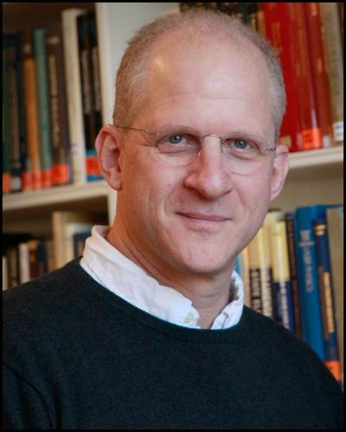

## John Martinis, Professor at the University of California, Santa Barbara

Received the 2014 Fritz London Memorial Prize, shared with Michel Devoret and Robert Schoelkopf, for his fundamental and pioneering experimental advances in quantum control, quantum information processing and quantum optics with superconducting qubits and microwave photons. His research focusses on building a quantum computer using superconducting qubits. He recently teamed up with Google’s Quantum Artificial Intelligence Lab to join efforts in building quantum information processors.

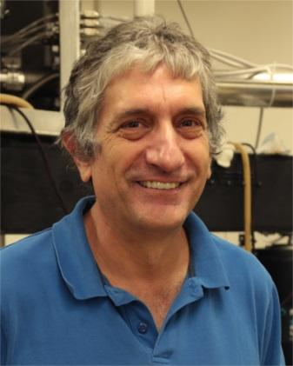

## Markus Matthes, Executive Vice President Design and Engineering at ASML

Markus received his engineering doctorate degree in Continuum Mechanics and now holds the position of Executive Vice President Design and Engineering at ASML. ASML is world-renowned for their cutting-edge lithographical production processes, which are responsible for a large part of global chip manufacturing.

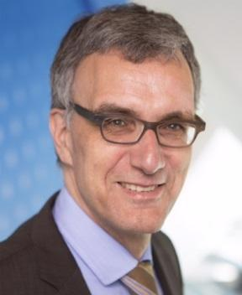

## Mike Mayberry, Corporate Vice President and Managing Director of Intel Labs

Received his Ph.D. in physical chemistry from the University of California, Berkley. As the vice president who leads Intel’s research team, he is responsible for Intel’s research efforts in computing and communications, and leads the Corporate Research Council. Intel has shown great interest in quantum computation and recently committed both a large financial investment and engineering expertise and resources towards quantum computing research.

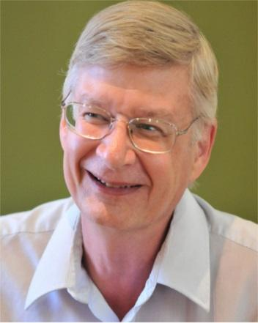

## Cora van Nieuwenhizen, European Parliament

Ms. **Cora van Nieuwenhuizen** MEP (1963) was elected to the European Parliament in 2014 on behalf of the Dutch liberal party VVD. She is a member of the parliamentary committees ECON (Economic and Monetary Affairs) and ITRE (Industry, Research and Energy). Moreover, Ms. Van Nieuwenhuizen is the Vice-chair of the European Parliament Delegation for relations with India, and a Member of the Science and Technology Options Assessment Panel of the European Parliament.

Ms. Van Nieuwenhuizen works on financial services regulation, the Euro, tax, space policy, the Digital Single Market and science and innovative technologies. With respect to science, subjects like Big Data, cloud computing and digitisation of industries are on her agenda. Since October 2014, Ms. Van Nieuwenhuizen has been involved in promoting funding for Quantum research in Europe.

Prior to her election to the European Parliament, Ms. Van Nieuwenhuizen was a Member of the Dutch Parliament and Chair of the Parliamentary Finance Committee. She has also served as Regional Minister for Infrastructure and Mobility in the province of Noord-BrabantCora is an MEP and a member of the Group of the Alliance of Liberals and Democrats for Europe and is a member of the Committee on Economic and Monetary Affairs. Having been an MP in 2010, she was then elected to MEP four years later. Her focuses are on water transport, aviation and energy policies. She is also a Panel Member of the EP's Science and Technology Options Assessment (STOA).

## Maive Rute, Deputy Director-General at the European Commission's Joint Research Centre (JRC)

Maive Rute joined the European Commission in 2005 to become Director for the Promotion of SMEs, Competitiveness and Entrepreneurship in DG Enterprise and Industry. She brought in her extensive management experience in the Estonian private and semi-public sector, notably five years spent as CEO of the Estonian Credit and Export Guarantee Fund KredEx.

In the Commission, Ms Rute also worked as Director for Biotechnologies, Food and Agriculture Research and as a Resource Director in DG Research and Innovation until April 2016.

Ms Rute graduated as an agricultural economist from the Estonian University of Life Sciences and holds an MBA from the Danube University Krems, Austria, and received an MA in international politics from CERIS, Brussels.

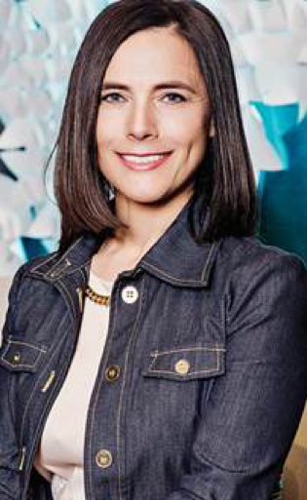

## Krysta Svore, Leading Researcher of the Quantum Architectures and Computation Group, Microsoft Research

Dr. Krysta Svore is a Senior Researcher and Research Manager at Microsoft Research in Redmond, Washington, where she leads the Quantum Architectures and Computation group. Svore’s research includes the development and implementation of quantum algorithms, including the design of a software architecture for translating a high-level quantum program into a low-level, device-specific quantum implementation, and the study of quantum error correction codes to enable fault tolerance and scalability. She has also developed machine-learning methods for web applications, including ranking, classification, and summarization algorithms. Dr. Svore received an ACM Best of 2013 Notable Article award. In 2010, she was a member of the winning team of the Yahoo! Learning to Rank Challenge. She received her Ph.D. in Computer Science with highest distinction from Columbia University in 2006 and her B.A. from Princeton University in Mathematics and French in 2001. She is a Senior Member of the Association for Computing Machinery (ACM), serves as a representative for the Academic Alliance of the National Center for Women and Information Technology (NCWIT), and is an active member of the American Physical Society (APS). She also currently serves as Chair of the Steering Committee for the Quantum Information Processing (QIP) Conference.

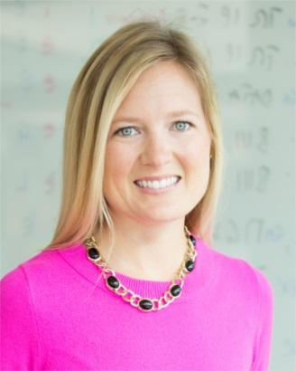

## Anton Zeilinger, Professor at the Vienna Center for Quantum Science and Technology and President of the Austrian Academy of Sciences

He received the Inaugural Isaac Newton Medal of the Institute of Physics (UK) in 2008, the citation succinctly sums up his achievements: “For his pioneering conceptual and experimental contributions to the foundations of quantum physics, which have become the cornerstone for the rapidly-evolving field of quantum information.” His research has centered around quantum entanglement of both photons and atoms, with his most significant contribution being the discovery of GHZ states, alongside Greenberger and Horne and their first experimental realization. These multi-particle entanglement states and their generalization have become essential in quantum information science, most notably in quantum computation.

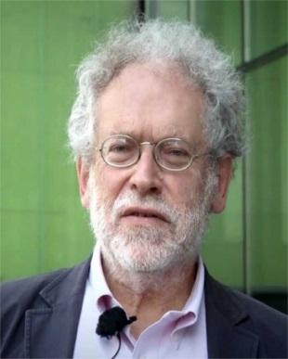

# Lab Tour QuTech in Delft

**Meet the scientists of QuTech**

The primary focus of QuTech is the development of quantum technology, such as inherently secure quantum network connections and quantum computers. On Wednesday 18 May, you have the opportunity to visit the quantum institute of TU Delft and TNO. Join the guided lab tours and meet the people of QuTech!

**Program**

Arrival in Delft at 14:30  
Guided tours start at 14:45  
The program ends at 16:00

Buses depart from Delft to Amsterdam at 16:30

Maximum 100 participants

# Hosting Committee

Freeke Heijman (EU Presidency, Ministry of Economic Affairs)

Thierry van der Pyl (European Commission, DG CNECT)

Leo Kouwenhoven (QuTech)

# Programme Committee

Tommaso Calarco (Chair, IQST Ulm University)

Immanuel Bloch (Ludwig Maximilian University of Munich and Max Planck Institut für Quantenoptik)

Harry Buhrman (CWI, QuSoft)

Ignacio Cirac (Max Planck Institut für Quantenoptik)

Trevor Cross (e2v)

Daniel Esteve (CEA/Saclay)

Nicolas Gisin (University of Geneva)

Steffen Glaser (Technical University München)

Charles Marcus (University of Kopenhagen, QDev)

Richard Murray (Innovate UK)

Gregoire Ribordy (ID Quantique)

Iuliana Radu (IMEC)

Thomas Strohm (Robert Bosch GmbH)

Lieven Vandersypen (QuTech, TU Delft)

Rogier Verberk (QuTech, TNO)

Ian Walmsley (University of Oxford)

# Organizing team

Floor van de Pavert (Lead organizer, Independent Consultant)

Hadewich Hoos (Ministry of Economic Affairs)

Sandra Kennes-Ori (Ministry of Economic Affairs)

Arjan Nijnatten (Ministry of Economic Affairs)

Heera Dijk (QuTech)

Servaas Duterloo (QuTech)

Marceline du Prie (QuTech)

Chantal Smith (QuTech)

# Manifesto writing team

Tommaso Calarco (University of Ulm)

Ignacio Cirac (Max Planck Institute)

Freeke Heijman (NL EU presidency)

Charles Marcus (Niels Bohr Institute)

Richard Murray (Innovate UK)

Aymard de Touzalin (European Commission)

**Quantum Technology Exhibition**

An ambitious, long-term, flagship-scale initiative combining education, science, engineering and innovation across Europe is needed in order to unlock the full potential of quantum technologies’

*Quantum manifesto – February 2016*

Quantum technologies shows real potential for the transition of world leading science into prosperity for the Union. To unleash this potential, strong support is needed from the European Commission and member states to help build the connections, and to provide support to an eco-system of education, science, engineering and innovation, each of which delivers a vital ingredient to future prosperity, security and health. This exhibition shows a snapshot of that future European eco-system. It will help you to see for yourself the huge potential that quantum technologies will have for the European Union, and the strength and breadth of expertise that can be found within European universities, RTOs and companies.

This exhibition has been designed to showcase examples of best practice in each of the areas of education, science, engineering and innovation, and to show the connections that a future European programme would enable between these activities to achieve success. The progression of four themes are marked between the exhibits, in different coloured lines, showing the connections between: quantum sensors, communications, simulation and computing.

**Exhibitors**

**Education**

IQST graduate school on quantum science and technology

Centres of Doctoral Training (UK)

**Science**

Quant-ERA

**Science and Engineering**

QuTech (Communication, computing)

Quantum hub for sensors and metrology – University of Birmingham (Sensing)

QuSoft (Computing)

Centre for Quantum Devices – University of Copenhagen

Qtech

INRIM and the Italian Quantum Backbone, IT

University of Innsbruck

**Innovation- Components and Materials**

Toptica

Single quantum

Element 6

**Innovation- Systems**

Muquans – Quantum Gravimeter (sensing)

ID Quantique (communication)

**Innovation- End users**

Airbus (sensing, communication, simulation, computing)

Robert Bosch GmbH (sensing)

# Map of the venue

